Experiment 1: Hello World Script
Aim:
To create and execute a basic Bash script that displays 'Hello, World!'.
Requirements:
- Linux/Unix environment with Bash shell
- Text editor (nano, vim, etc.)
Algorithm / Steps:
Open a terminal.
Create a new file hello.sh.
Add the shebang line and print statement.
Save and exit.
Make the file executable using chmod +x hello.sh.
Run the script
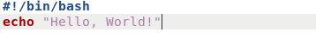

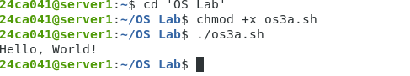

Experiment 2: Basic Calculator
Aim:
To perform addition, subtraction, multiplication, and division of two numbers using a Bash
script.
Requirements:
- Bash shell
- Basic knowledge of arithmetic operators
Algorithm / Steps:
Prompt user for two numbers.
Perform arithmetic operations.
Display results.
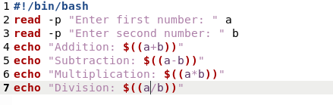

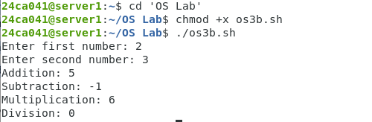

Experiment 3: Odd or Even Checker
Aim:
To check whether a given number is odd or even.
Requirements:
- Bash shell
Algorithm / Steps:
Take a number as input.
Find remainder using modulo operator.
If remainder is 0 → Even, else Odd
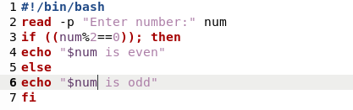

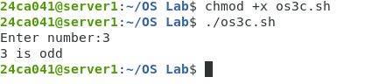

Experiment 4: File Existence Checker
Aim:
To check if a file exists in the current directory.
Requirements:
- Bash shell
Algorithm / Steps:
Accept filename from user.
Use -f to check existence.
Display appropriate message
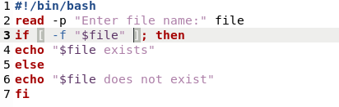

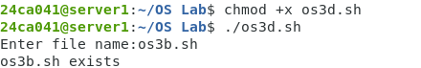

Experiment 5: Current Date and Time
Aim:
To display the current system date and time.
Requirements:
- Bash shell
Algorithm / Steps:
Use date command to get current date and time.
Display it to the user.

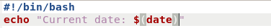

Experiment 6: Directory Size Monitor
Aim:
To display the size of a given directory using du command.
Requirements:
- Bash shell
- Knowledge of du command
Algorithm / Steps:
Prompt user for a directory path.
Use du -sh to get size.
Display result.
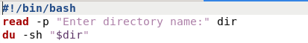

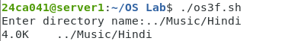

Experiment 7: Backup Script
Aim:
To copy all .txt files from one folder to another with a timestamp.
Requirements:
- Bash shell
- Knowledge of cp command
Algorithm / Steps:
Prompt source and destination directories.
Use date command for timestamp.
Copy files.
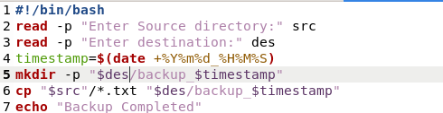

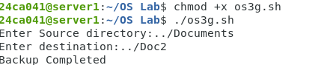

Experiment 8: Simple Login Simulation
Aim:
To simulate login by verifying username and password.
Requirements:
- Bash shell
Algorithm / Steps:
Store predefined username and password.
Prompt user for credentials.
Verify and display login result
